ISSACK WAITHAKA
cs-sa07-24085

Meow
The first thing I did was to start the machine
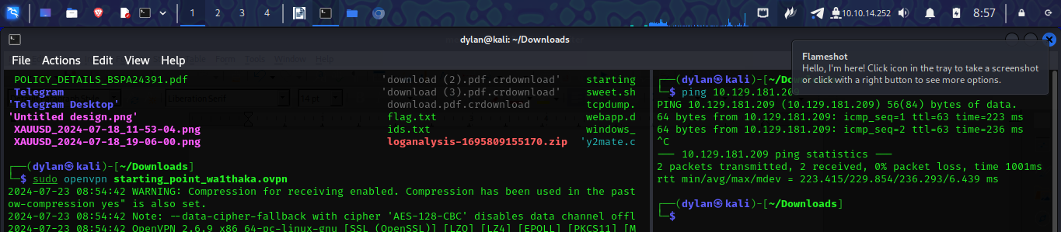
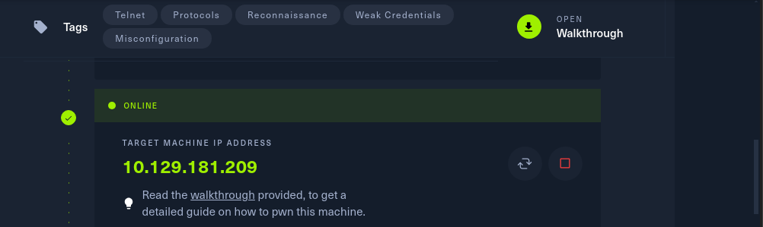

1.
The answer was Virtual Machine

2.
The answer was terminal


3.
The answer was openvpn
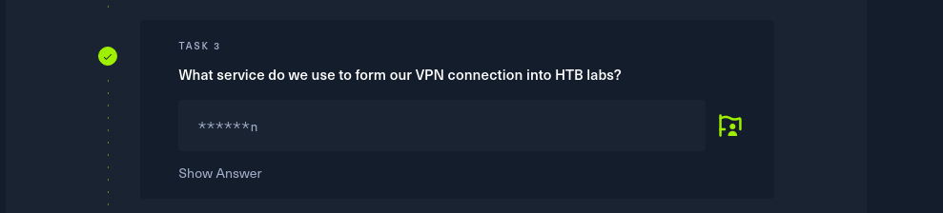

4.
The answer was ping
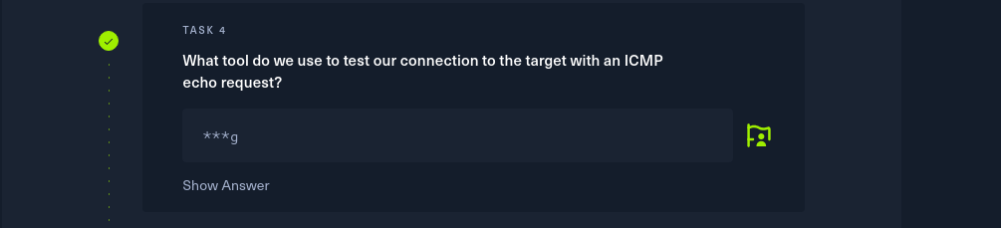

5.
The answer was nmap

6.
The answer was telnet

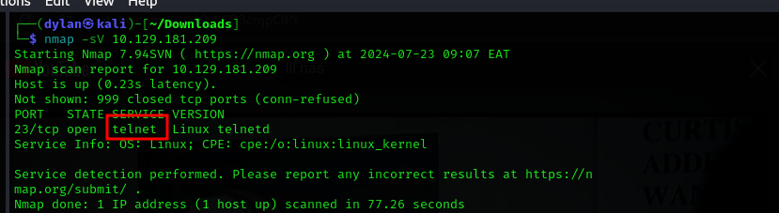
7.
The answer was root

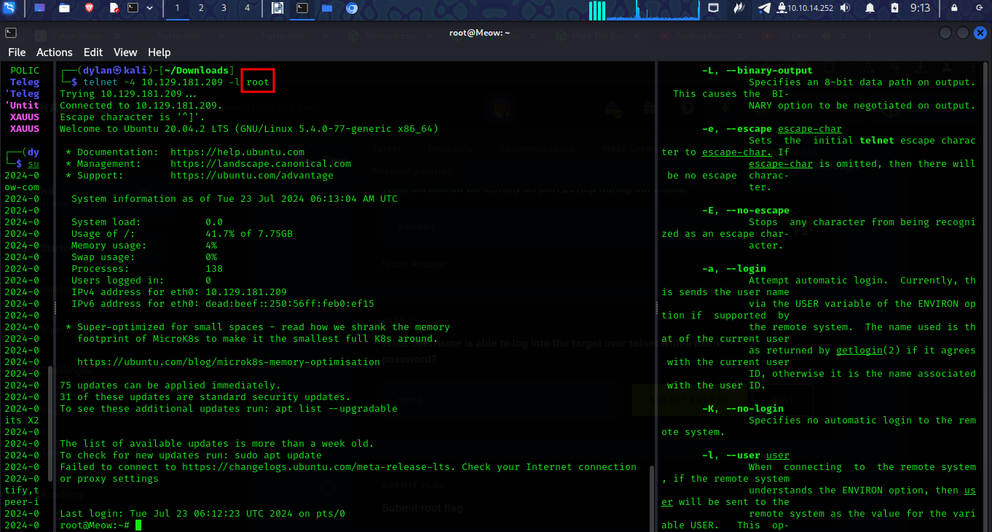

8.
The flag was b40abdfe23665f766f9c61ecba8a4c19
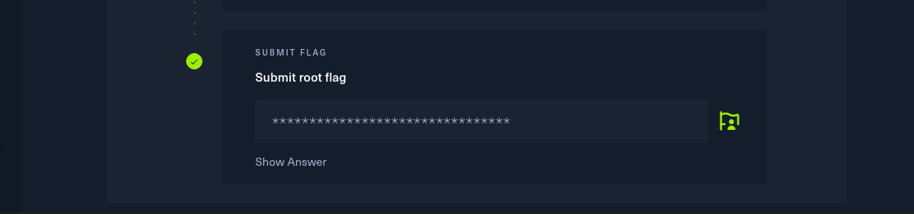
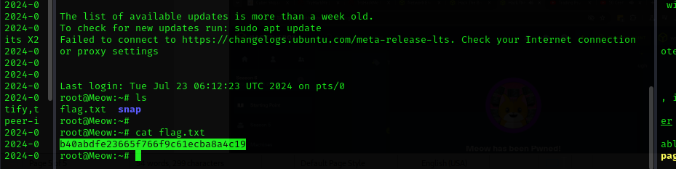

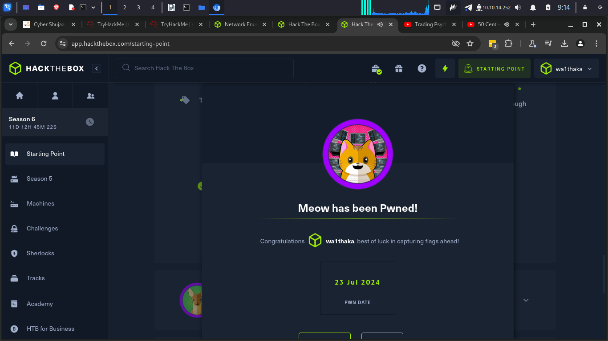

\
Conclusion
-In this section I was able to learn how to connect to telnet services

Fawn
-The first step was to spawn the machine


1.
The answer was file transfer protocol

2.
The answer was port 21

3.

The answer was SFTP. This is the secure version of FTP.
4.
The answer Is ping

5.
The answer was vsftpd 3.0.3

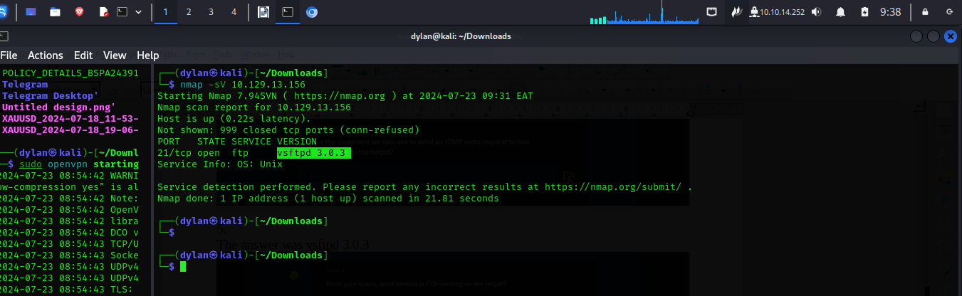
6.
The answer was unix

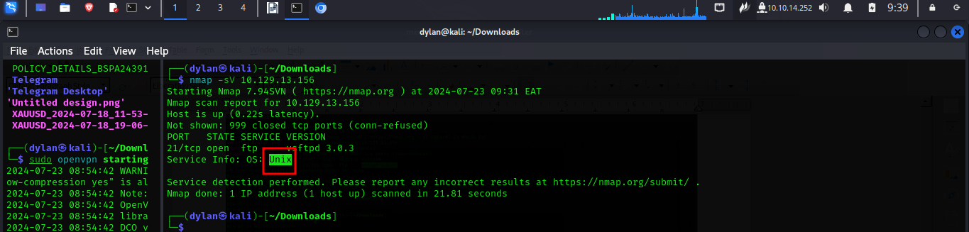
7.
The answer was ftp -h

8.
The answer was anonymous

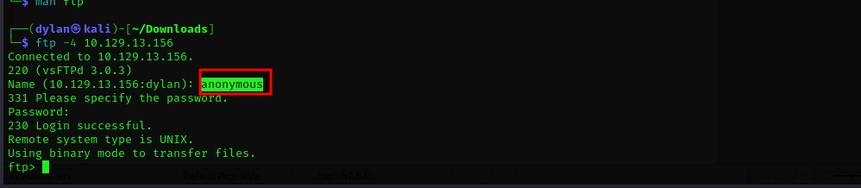

9.
The answer was 230

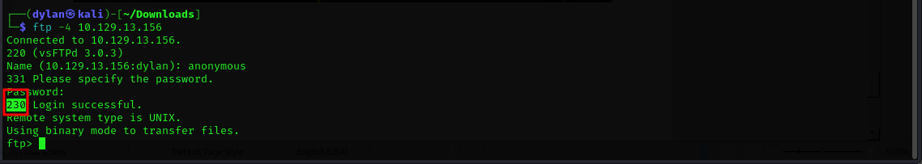
10.
The answer was ls
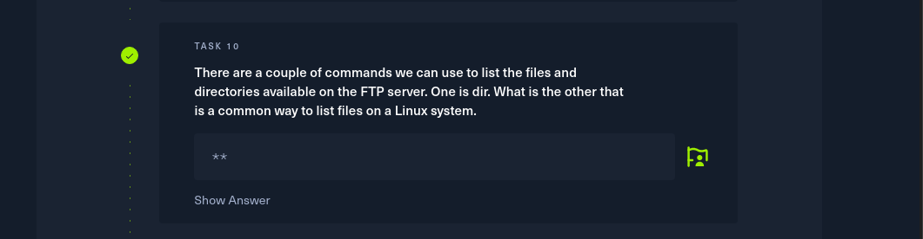
11.
The answer was get
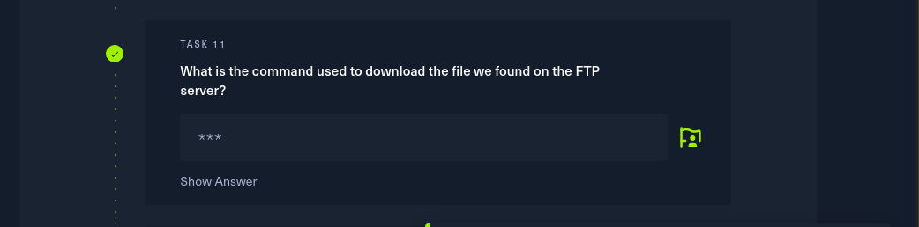

12.
The answer was 035db21c881520061c53e0536e44f815

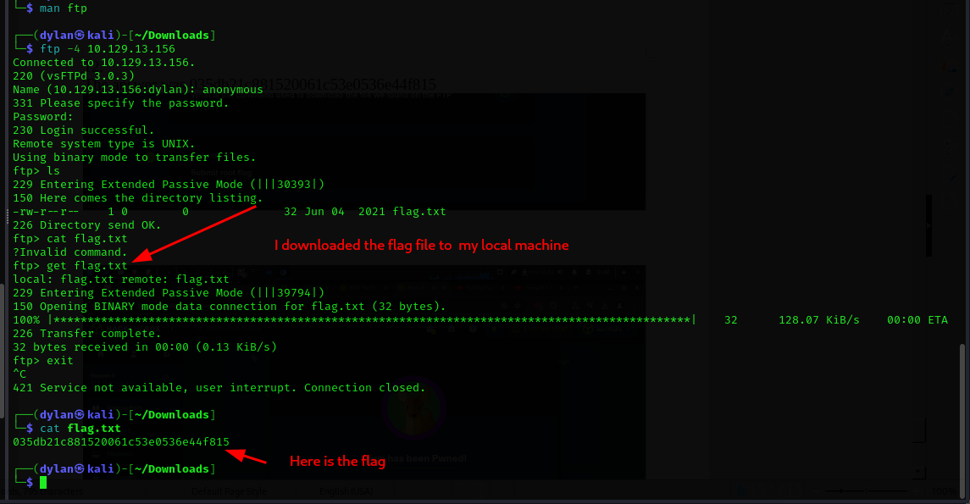
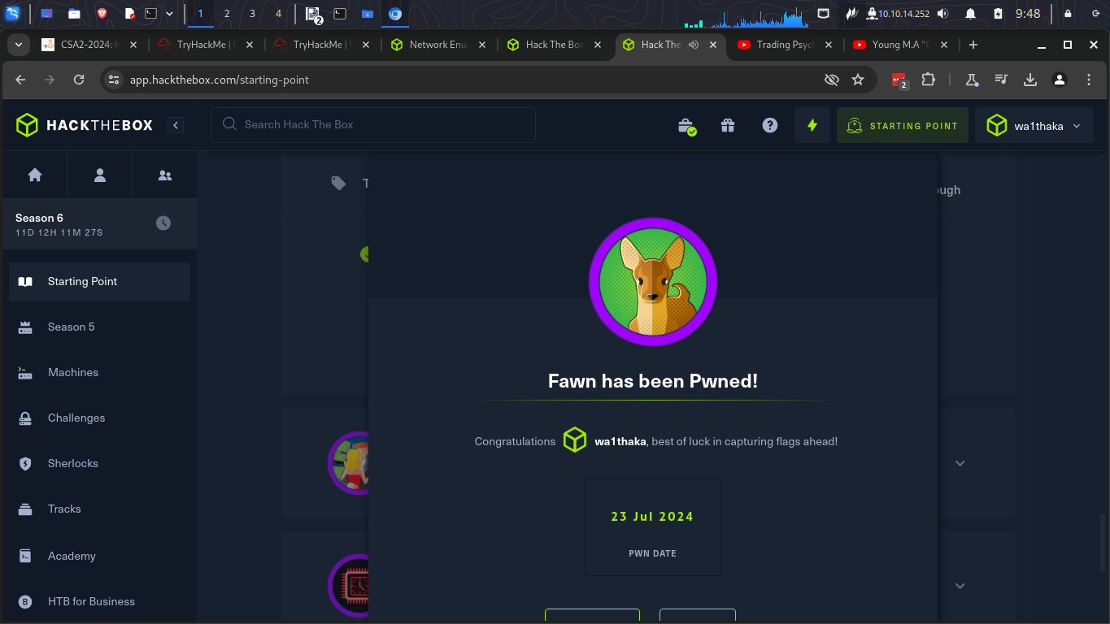
Conclusion
In this room I learnt how to connect to FTP

Dancing
I stared by spawning the target machine


1.
The answer was server message book
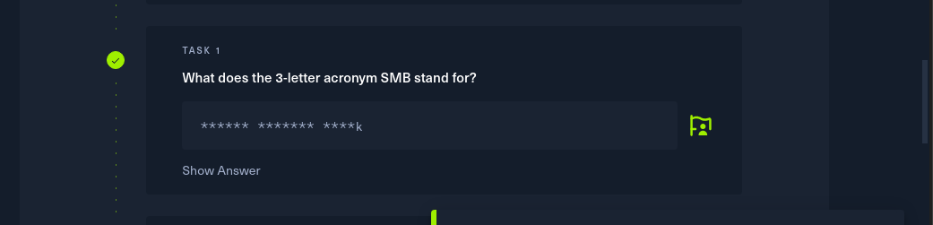
2.
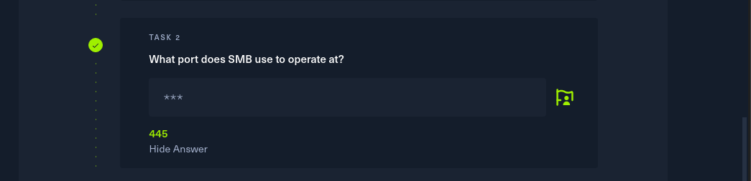

3.

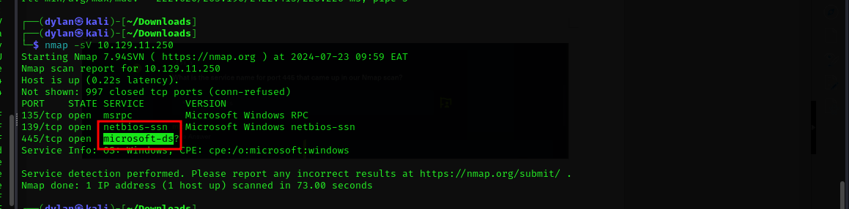

4.
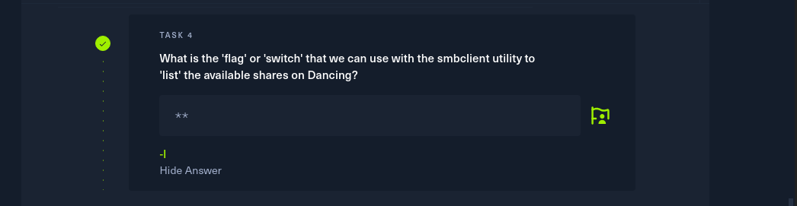
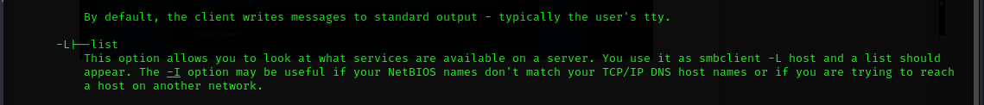

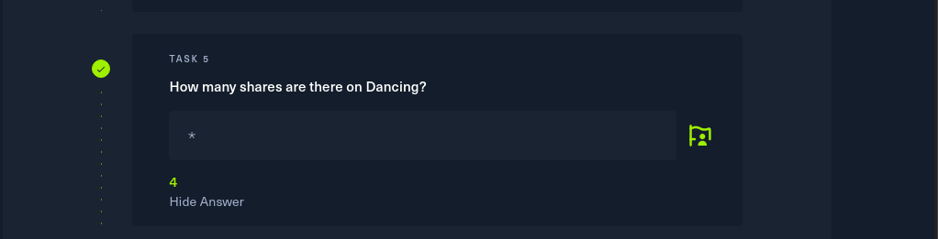
5.

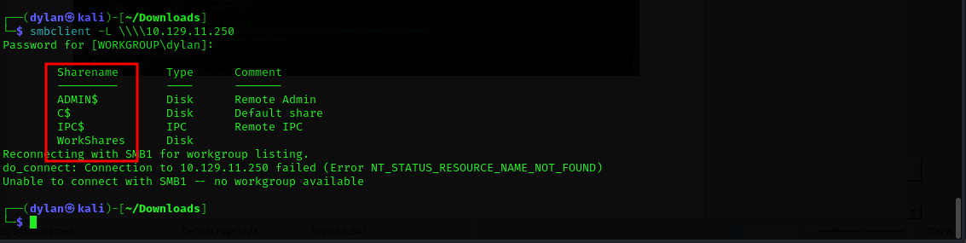

6.
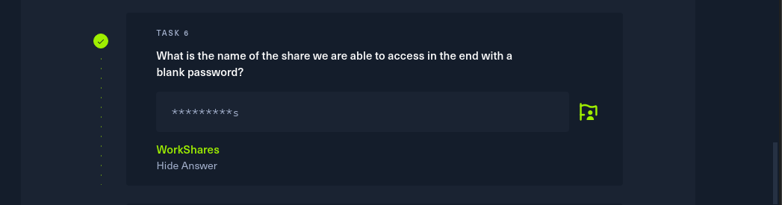
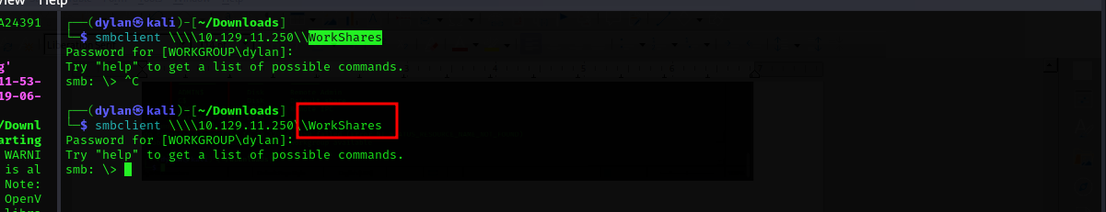

7.
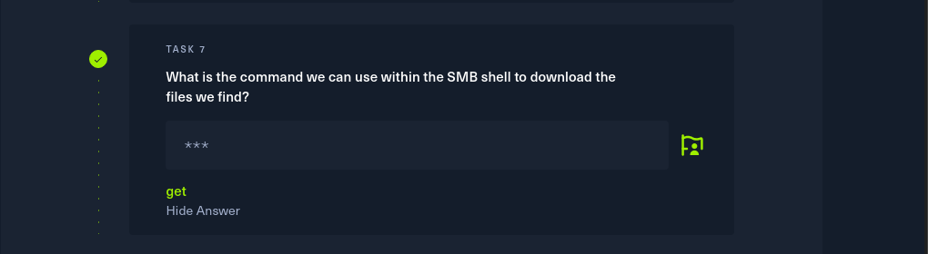

8.
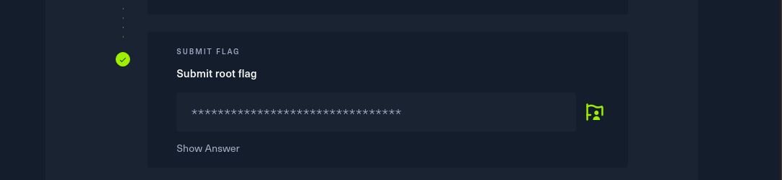
After gaining access I navigated to the James.p directory where I got the flag

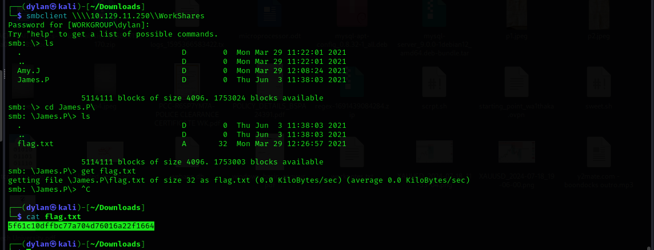

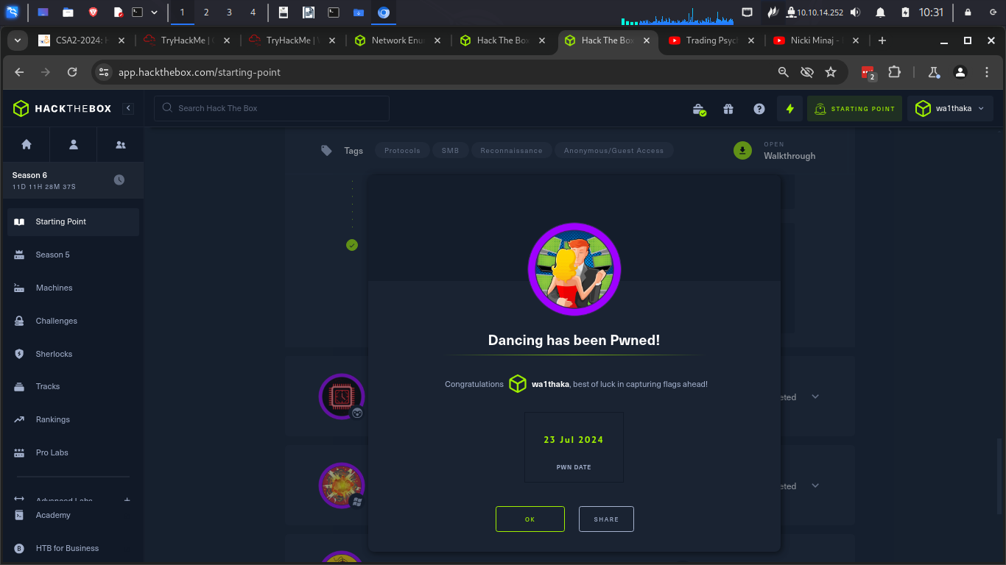

Conclusion
- In this section I learned how to connect and access an smb server

Redeemer
- The first step was to spawn the target machine
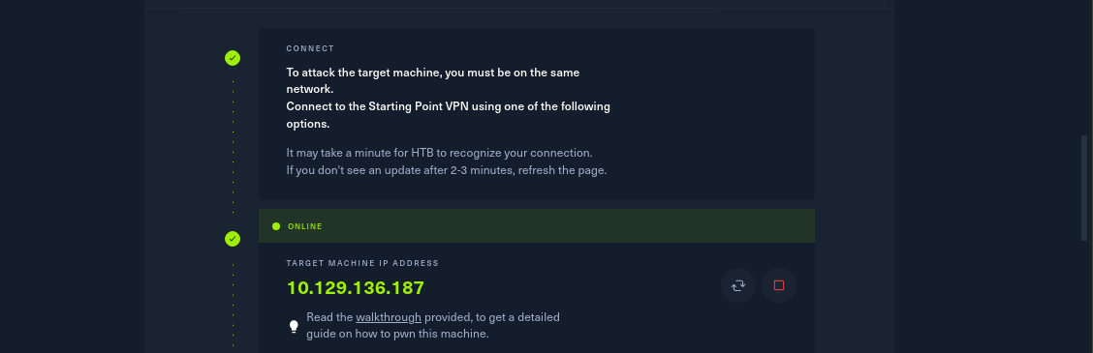
1.

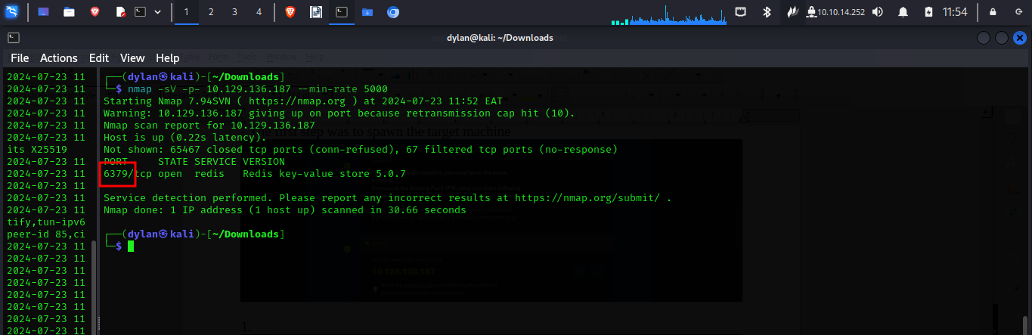
2.

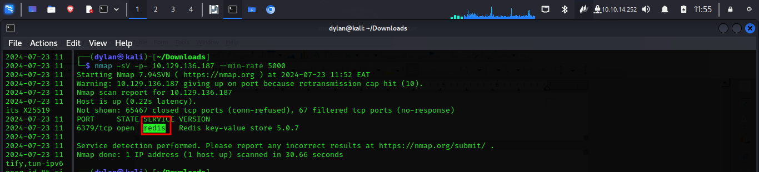

3.


4.



5.
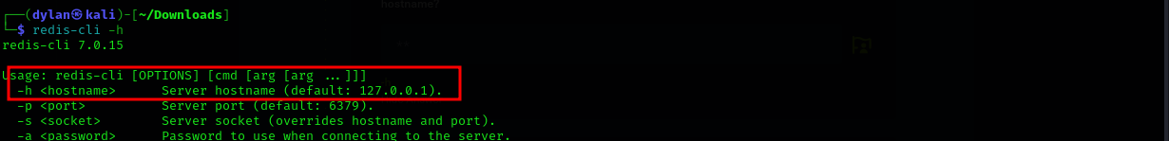

6.


7.

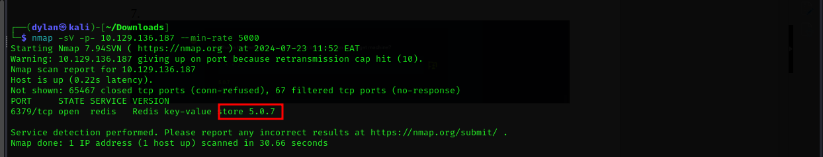

8.


9.

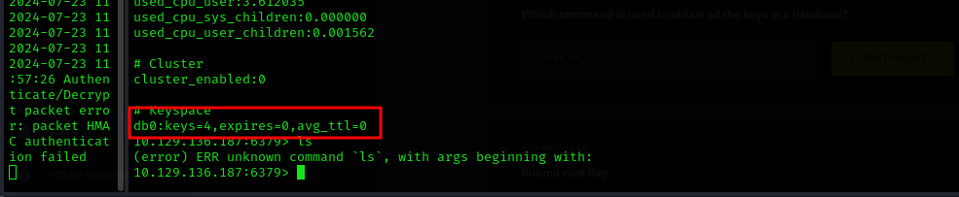

10.


11.

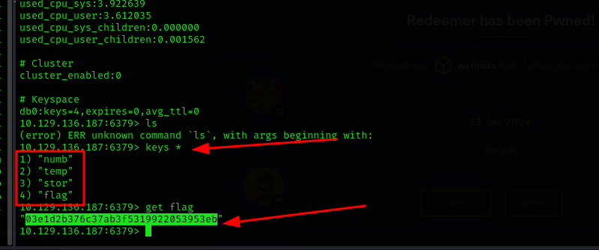
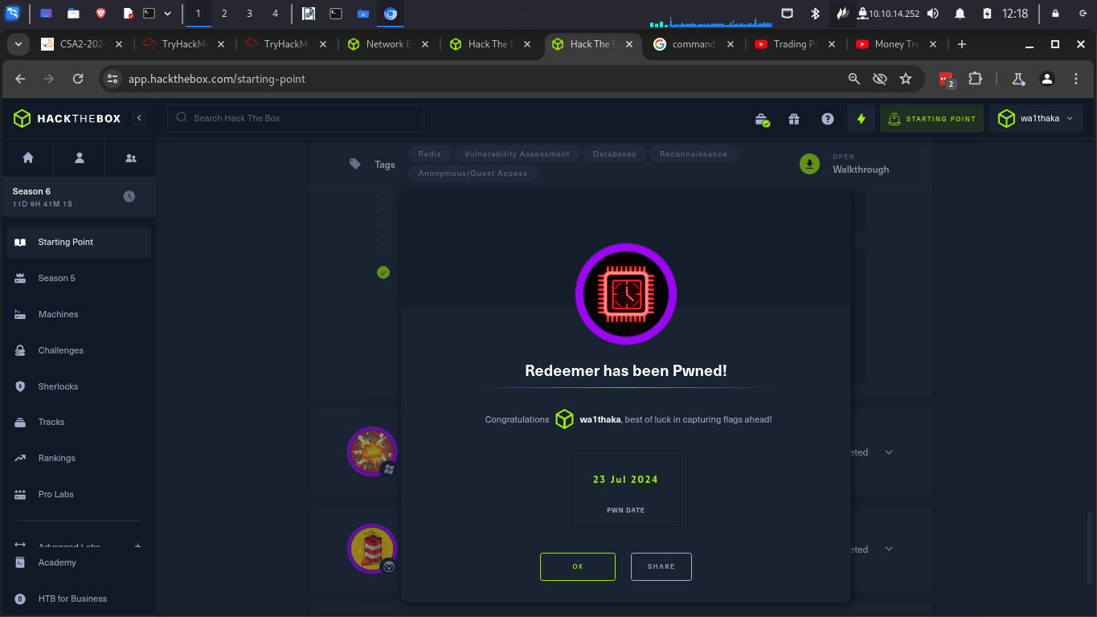

Conclusion
In this section I learnt how to connect and navigate through the redis databases

